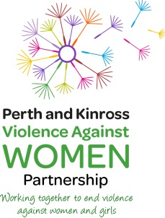
FREE LEARNING OPPORTUNITY

Kaleidoscope – a dramatic presentation by Naomi Breeze
Tuesday 28 November 2017
1230 – 1330hrs
Perth Museum and Art Gallery
Target Audience: If you work in education, health, housing, social work, policing, public protection – you need to see this!

To book your place through Eventbrite Please click here

The Perth and Kinross Violence Against Women Partnership (PKVAWP) are pleased to organise and support this Seminar as part of the 16 Days of Action against Domestic Abuse Campaign. This event is supported by Perth and Kinross Child Protection Committee (CPC) Be Challenged at Lunchtime

Naomi Breeze is a graduate of the Royal Scottish Academy of Music and Drama and a member of Equity. She writes, performs and tours her one person plays on a wide range of topics including homelessness, domestic abuse, anti-social behaviour and gender violence and mental health. Kaleidoscope explores the issues of coercive control within an intimate relationship and challenges widely held views that physical violence is the only, or most destructive, form of violence against women.

Violence Against Women Webpage Child Protection Committee Webpage

