Monday 27 November
6.30pm

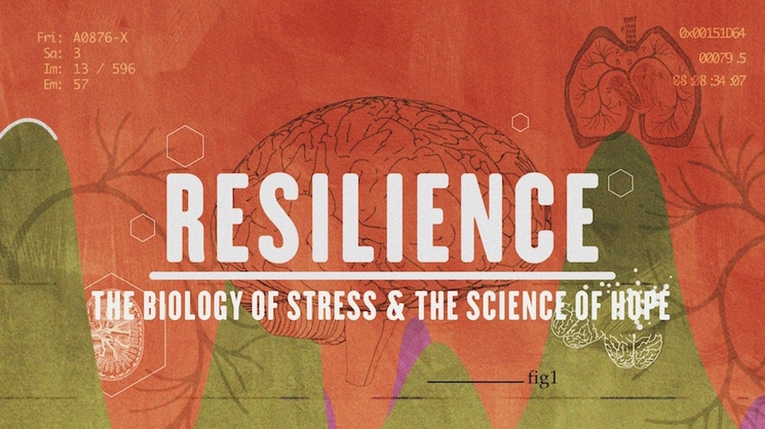
A ground-breaking new film on the biology of stress and Adverse Childhood Experiences and its links to major illnesses.
The original research was controversial, but the findings revealed the most important public health findings of a generation. RESILIENCE is a one-hour documentary that delves into the science of Adverse Childhood Experiences (ACEs) and the birth of a new movement to treat and prevent Toxic Stress. Now understood to be one of the leading causes of everything from heart disease and cancer to substance abuse and depression, extremely stressful experiences in childhood can alter brain development and have lifelong effects on health behaviour.
.
Followed by refreshments and the chance to discuss the film.

